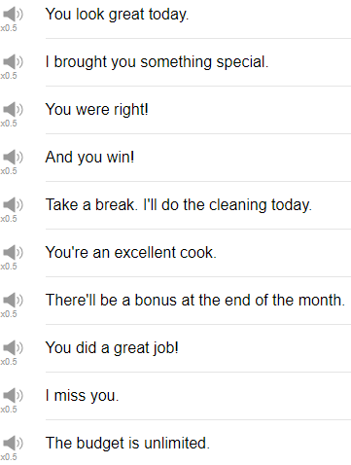

|  |
| --- |
| Hi, everybody! My name is Alisha, and today we’re going to be talking about 10 Phrases That You Always Want to Hear. So let’s begin! |
| 1. You win! |
| The first phrase is you win, you win. If you hear the phrase you win, it means you have won something. You are probably going to receive something for free! woohoo! That’s a very happy thing, right? You want to get free things. |
| Congratulations, you win a car! Yay! |
| Here are the keys to your new car. great, thank you, umm. |
| 2. I brought you something special. |
| This is exciting to hear because it means this little something special. It’s like oh I thought only of you, so I brought you this. I brought you something special, really, thank you. |
| 3. I miss you |
| I miss you. I miss you is nice. You can use this with your friends, your family members, your partner, whoever. I miss you shows that you want to meet the other person. Probably you haven’t seen them as much as you would like to. So you can say I miss you, I miss you. Call your husband or wife or boyfriend or girlfriend, whoever on the phone maybe. You haven’t seen them for a long time, you can say I miss you. I miss you too. |
| 4. Take a break, I will do the cleaning today. Take a break, I will do the cleaning today. This means someone else is going to clean up your house for you or clean up something for you. I would be very happy to hear this phrase right now because my apartment is a disaster because I am only there to sleep. So maybe you’ve had a long day at work or a long day doing something and you come home and somebody else has offered to do this for you. So take a break, I will do the cleaning today, and you can reply, really, thank you so much! I am going to relax. |
| 5. The budget is unlimited. |
| The next phrase that you always wanted to hear is, the budget is unlimited. The budget is unlimited. This could be at work, this could be a budget, your personal budget, maybe, but it just means there is no limit to the budget. You can spend as much money as you want! Woohoo! Very exciting. |
| So let’s see. In a business context, perhaps you have this new client who is going to give you a lot of money to build a new house or something, maybe you are building houses, that’s your project. And your boss comes to you, the budget for this project is unlimited. Really, let’s go crazy! |
| 6. There will be a bonus at the end of the month. |
| Yeah, this is a phrase that you probably are very excited to hear. It means you are going to receive extra money from your job at the end of the month. Woohoo! Very exciting, extra money. Maybe you will hear this from your boss, your manager or maybe your co-worker at work or maybe see it in an email. There will be a bonus at the end of the month. Really, I am going to use mine to buy a new car, really. I am going to use mine to go out on a date, really. I am going to use mine to get a new fish. |
| 7. You did a great job. |
| You did a great job. You did a great job is something you will probably hear from – Well I don’t know. You could hear this from pretty much anybody, anytime you’ve done a good job, someone will congratulate you or tell you their opinion with this phrase. You did a great job. You finished a project at work and your boss says, you did a great job. Nice, thank you so much. It was really fun, or thank you. Just say thank you. |
| 8. You look great today. |
| You look great today. The other person thinks that your physical appearance is nice today. Don’t think about the today part, you know. Just take the compliment. Oh really, thank you so much. |
| You look great today. Oh thank you so much, I got a new haircut. Thank you so much, I got to sleep, yeah. |
| 9. You were right. |
| You were right. This means that something that you said in the past was correct. And everybody likes to be correct, I think. |
| I saw that movie that you recommended. You were right, it was really good. Oh good, I am glad you enjoyed it. |
| Don’t be like, I know or yeah I knew I was right. Don’t do that. Just say oh good, I am glad. |
| 10. You are an excellent cook. |
| You are an excellent cook. This is a nice compliment especially for someone who enjoys cooking, if you say you are an excellent cook, it means you enjoy their food. |
| So let’s see, at a dinner party for example, you are an excellent cook. This food is delicious. Oh thank you so much. I am really glad you enjoyed it. |
| And that’s the end. So those are things that you want to hear. So keep in mind, it’s nice for you to hear these things but other people also want to hear them too. So compliment other people. Tell them that they are awesome if they are awesome. Tell them that they have good skills in whatever it is that they like to do. People like to be complimented and people want to be liked. So write them a message or say something nice to them. Leave us a comment. We have a great team of people doing all these amazing things. So tell them how much you love them. So thanks so much for joining us for this week’s lesson. We will see you again next time. Please make sure to subscribe, if you have not already so that you don’t miss out on any fun stuff. Thank you very much again for watching and we will see you again soon, bye. |